





Booja devi D



Abiya V



Samiksha P



Virginia A.L



Sundara Raaman R.S



Sivanesan.R

DR.M.Ganesan

Assistant Professor CSE

MRS.Preeti Lotulker

MRS.Hannah Arun



Social Determinants of Health (SDOH) Data Are Often Disconnected, Underutilized, And Difficult To Integrate, Posing Several Challenges For Healthcare Organizations:

1. **Fragmented Data Sources:** SDOH data comes from multiple sources (e.g., census, environmental, and community datasets), making it difficult to consolidate and use effectively for healthcare planning.
2. **Complex Data Interpretation:** Community-level socioeconomic and environmental indicators are highly detailed and complex, which can be overwhelming for healthcare providers to interpret without advanced analytics.
3. **Lack of Summarization:** Current systems provide raw demographic or environmental data without concise insights, making it hard for decision-makers to focus on the most impactful factors influencing patient outcomes.
4. **Absence of Predictive Insights:** Existing tools often fail to integrate predictive analytics that combine clinical and social data, leaving healthcare providers without actionable insights to proactively address health risks or disparities.
5. **Inconsistent Data Formats:** Variability in data formats across agencies and sources creates inconsistencies, making it harder to extract standardized information for equity-focused healthcare interventions.
6. **Limited Visualization Capabilities:** Healthcare stakeholders lack intuitive, real-time visualizations of SDOH data that could highlight disparities and trends, limiting their ability to quickly identify at-risk populations and target interventions.

·

1. **Multi-Source Data Integration**  
   Combine SDOH datasets (CDC SVI, Census ACS, USDA, EPA) with patient health records to create a unified data ecosystem for healthcare analysis.
2. **Geocoding & Spatial Analysis**  
   Apply geocoding and spatial analysis techniques to connect community-level indicators with individual-level health outcomes for more precise insights.
3. **Secure Cloud-Based Infrastructure**  
   Utilize secure cloud storage and processing platforms (Supabase, PostgreSQL, AWS/Azure/GCP) to manage sensitive health and social data efficiently and securely
4. **Predictive Analytics Frameworks**  
   Implement machine learning models to analyze SDOH impact, predict health outcomes, and identify at-risk populations for early intervention.
5. **Dashboards & Data Visualization**  
   Develop interactive dashboards and visualization tools to present SDOH-driven insights in a clear and actionable format for healthcare stakeholders.



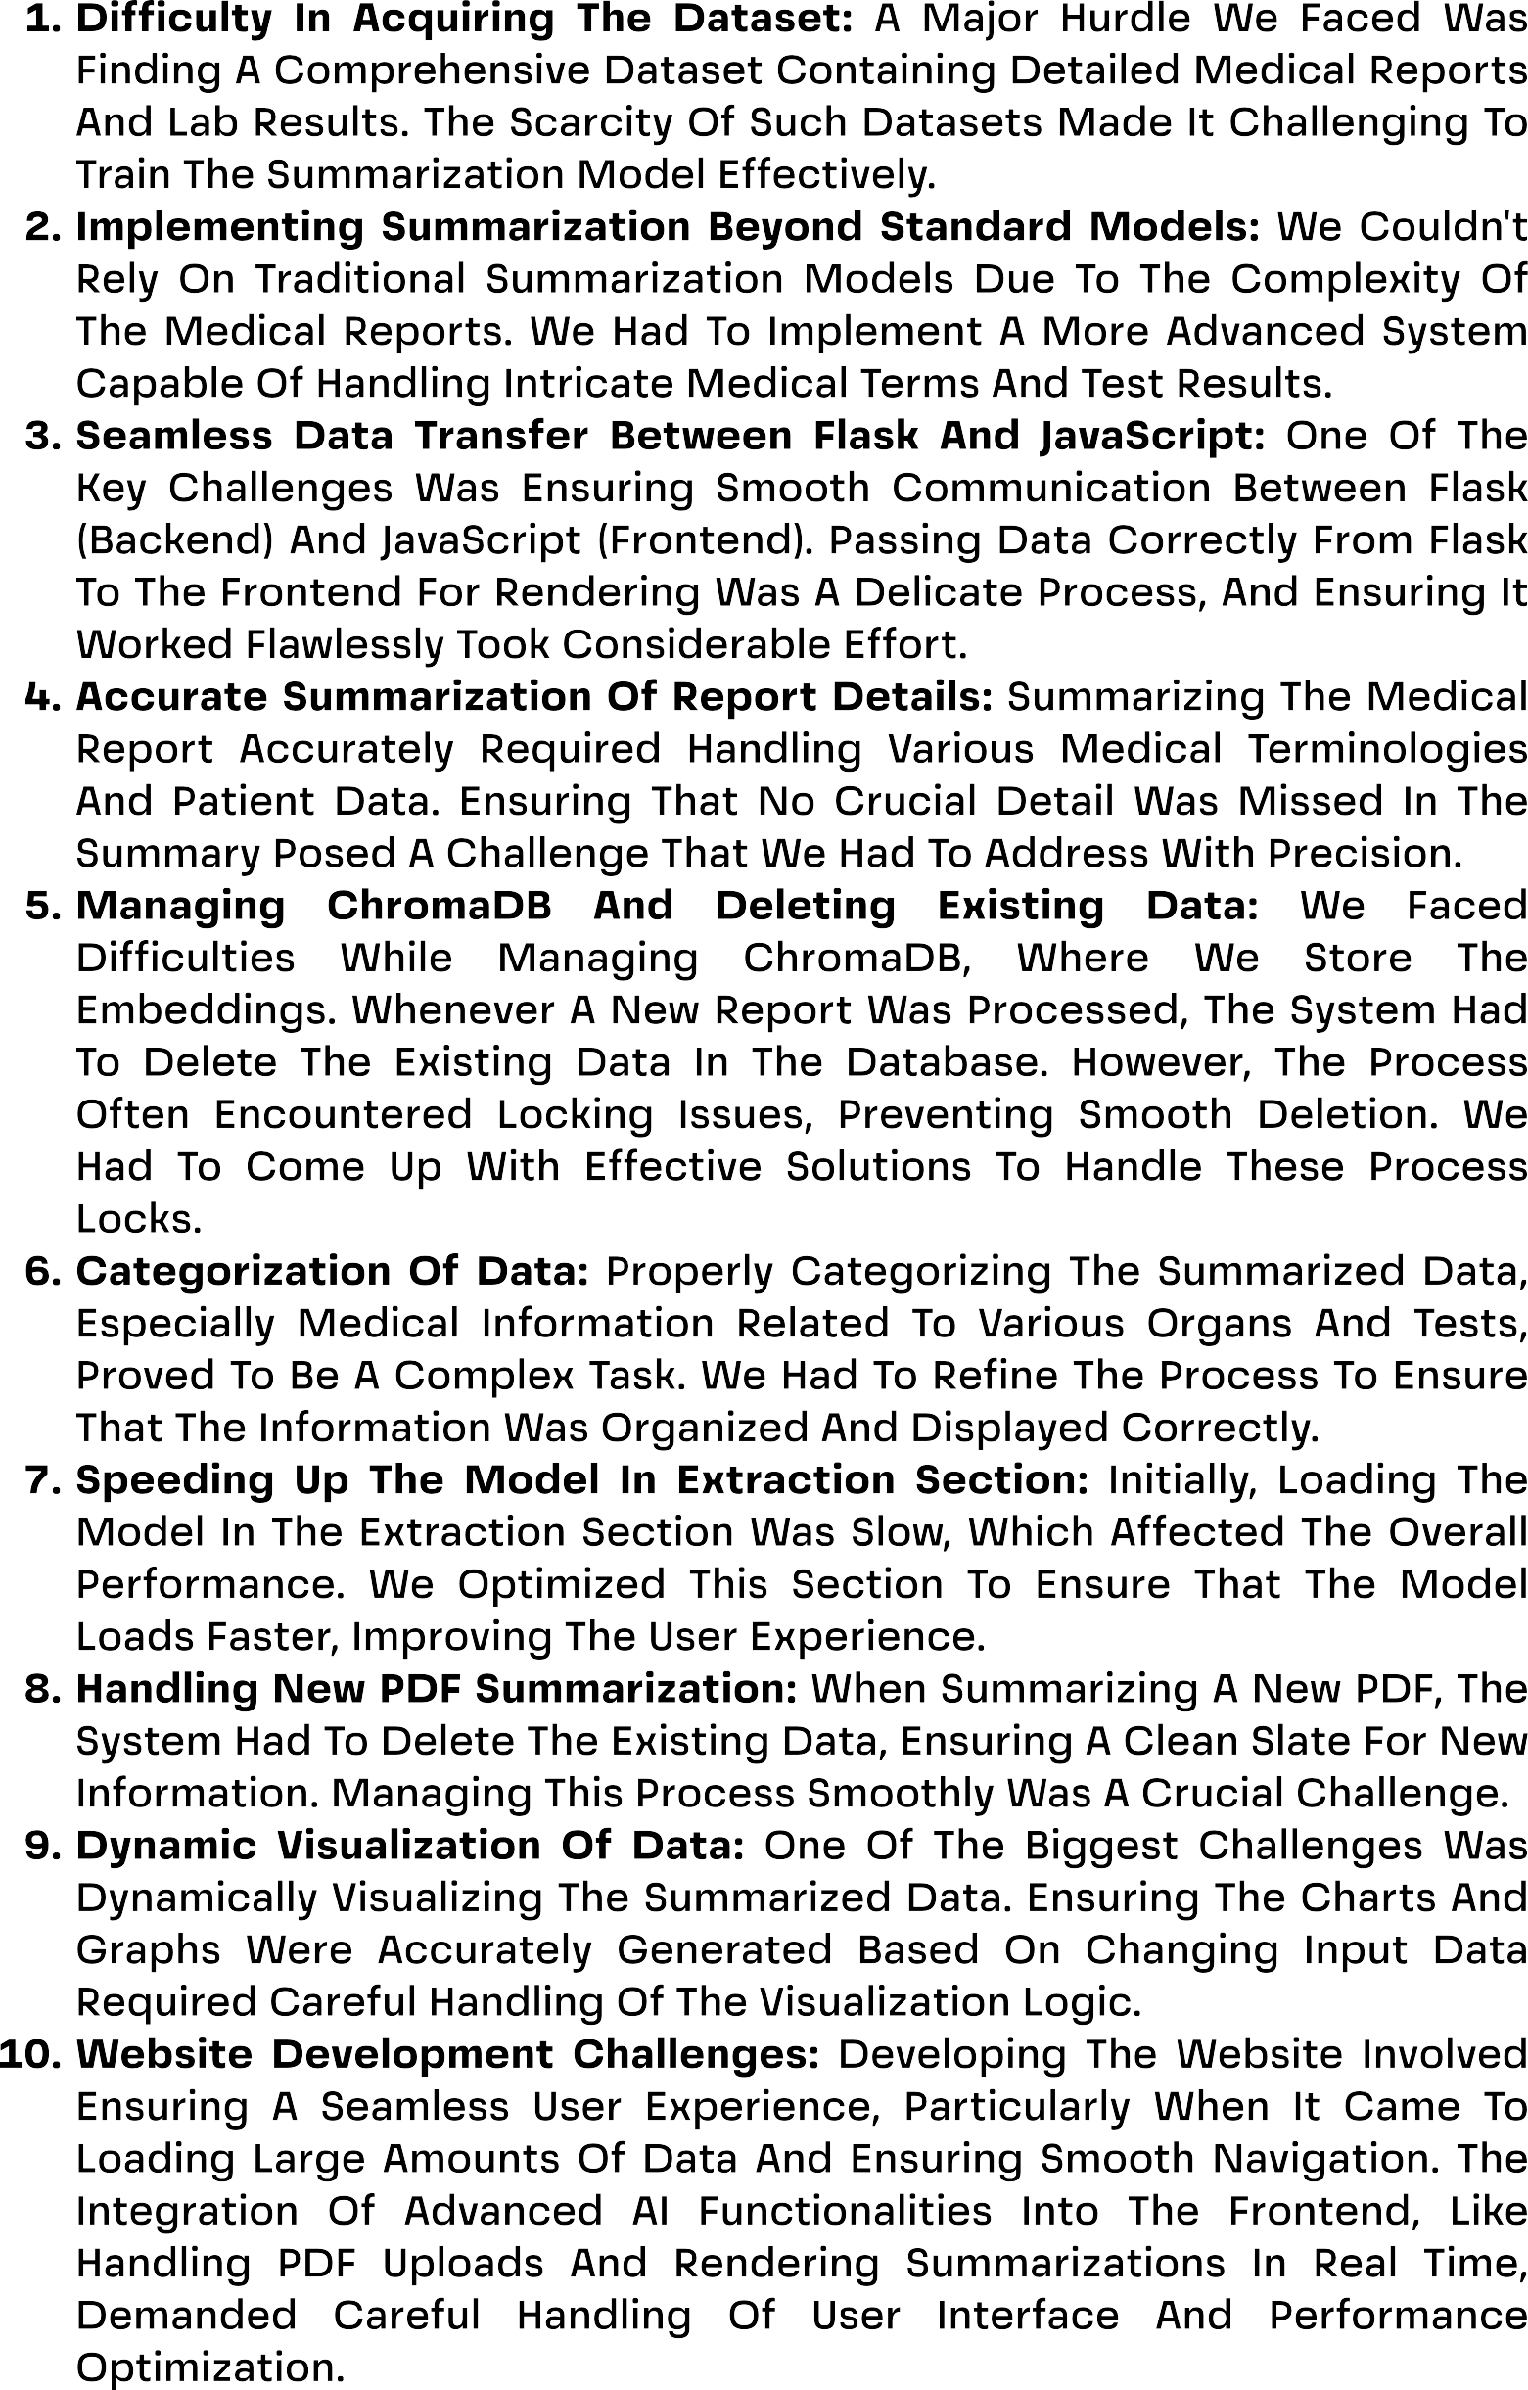



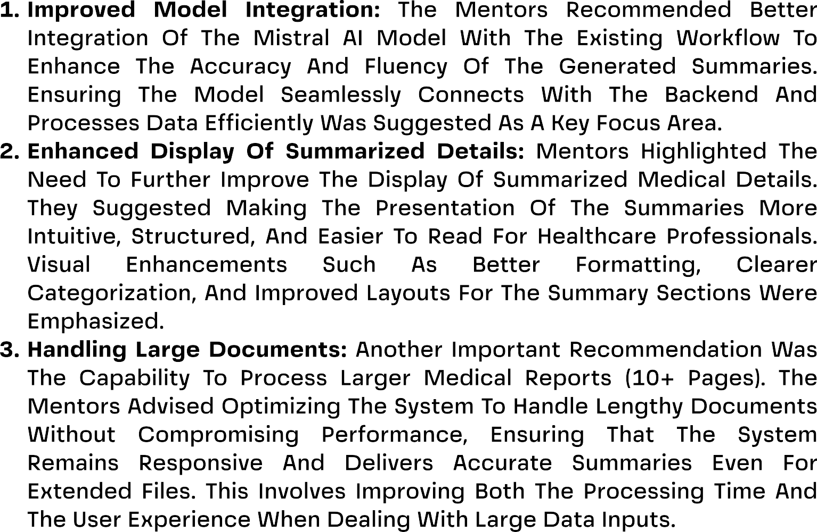



Booja Devi D

**Model Development (ML):** Designed, trained, and validated the machine learning model to process healthcare data. Ensured the model provided reliable outputs for predictive analysis and integrated it with the application pipeline.

Abiya V

**Backend With Supabase:** Implemented backend integration using Supabase, enabling Google Authentication for secure login. Developed and managed the Patient Registration form to ensure that user information is correctly stored and managed in the backend.

Samiksha P

**Backend With Supabase:** Worked on backend functionalities with Supabase, implementing role-based access control for secure data usage. Integrated login continuation using Google authentication for seamless access.

Sundara Raaman R.S

**Model Development (ML):** Collaborated in training and optimizing the machine learning models. Focused on enhancing accuracy and performance through advanced techniques, ensuring robust disease prediction and analysis.

Virginia A.L

**Frontend Development:** Contributed to designing and developing the frontend components of the application. Ensured usability, styling consistency, and seamless integration with backend functionalities.

Sivanesan R

**Frontend Development:** Developed and implemented the user interface for the application, ensuring responsive design and smooth interaction for users. Focused on maintaining an intuitive and consistent experience across pages.



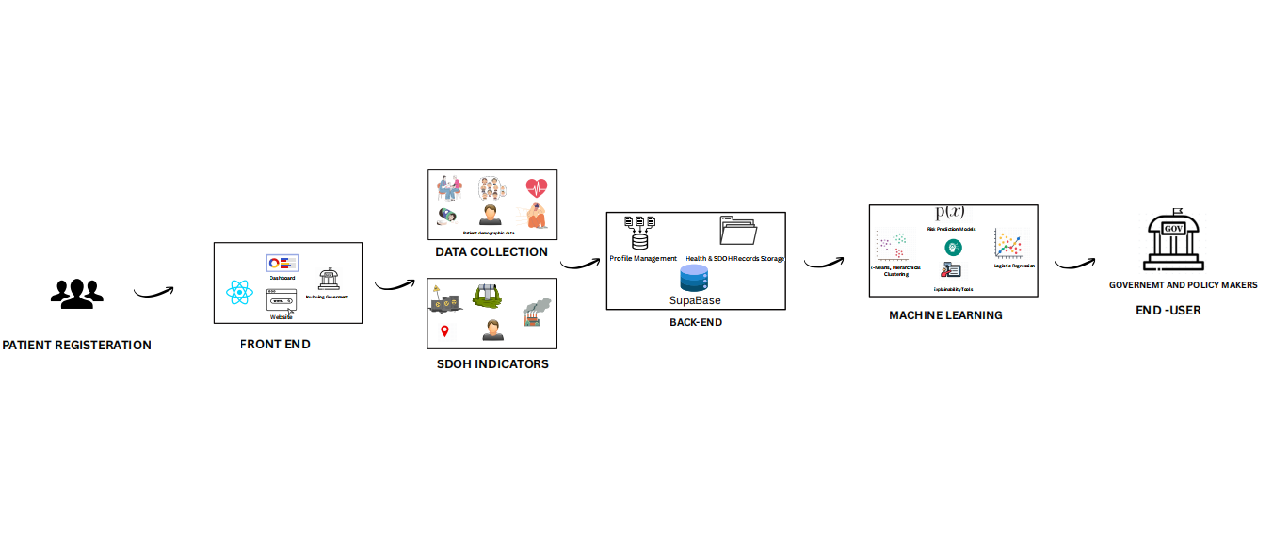



https://github.com/Boojadevi-24/NPN-AIML-CSE-1-SDOH-PLATFORM